Lesson Plan: Superhero-themed Adventure

Objective
Students will:
- Understand basic programming concepts: variables, conditionals, loops, and functions.
- Apply these concepts to create a superhero-themed Python project.

Preparation
- Materials:
  - Computers with Python installed.
  - Projector/ screen for code demonstrations.
- Setup: Ensure all students can access Python.

1. Introduction: Superhero Coding Powers!
- Engage: Show a slide with a superhero on a computer. Ask:
  - “What superpowers would you want if you could control a computer?”
- Connect: Explain how coding gives them superpowers to make computers do what they want.

2. Variables: The Superhero Backpack
- Explain: A variable is like a backpack that stores information, like a superhero’s tools.
  - Example Code:
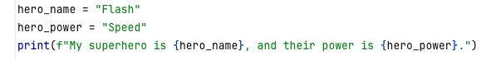
- Activity: Students create variables for their own superhero’s name and power.
- Discussion: “What other things could your superhero carry in their backpack?”

3. Conditionals: Superhero Decisions
- Explain: A conditional is a decision your superhero makes based on a situation.
  - Example Code:
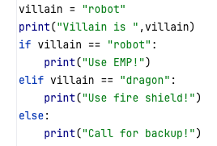
- Activity: Students create their own superhero decision tree using conditionals.
- Pair Discussion: Share their superhero’s decisions with a partner.

4. Loops: Superhero Training Drills
- Explain: Loops help superheroes practice or repeat actions without getting tired.
  - Example Code:
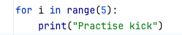
- Activity: Students write a loop to show their superhero practicing a move (e.g., “Run 5 laps!” or “Train punches 10 times!”).

5. Functions: Superhero Combo Moves
- Explain: A function groups actions into a combo move that can be reused.
  - Example Code:
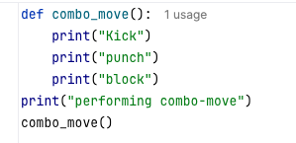
- Activity: Students write their superhero’s special move using a function.
- Pair Programming: Work in pairs to create two superheroes with combo moves that work together.

6. Project: Superhero Adventure Game
- Goal: Combine everything learned to create a simple superhero adventure.
  - Example Prompt: “Your superhero meets a villain and needs to decide how to defeat them. They repeat their training moves and finish with a special combo move.”
  - Encourage creativity and include:
    - Variables for the superhero name and power.
    - Conditionals for decisions.
    - Loops for actions.
    - Functions for special moves.
- Share: Students share their adventures with the class.

